Nama : Raden Sadiah Maharani

NIM : 2107126368

Basis Data Lanjut

Praktikum 3

1. Create one query that will convert 25-Dec-2004 into each of the following (you will  have to convert 25-Dec-2004 to a date and then to character data):
2. December 25th, 2004
3. DECEMBER 25TH, 2004
4. 25th december, 2004

→ a) SELECT TO_CHAR

(TO_DATE('25-Dec-2004','DD-MM-YYYY'),

'fmMonth ddth, YYYY')

AS "Date"

FROM Dual;

Result :



b) SELECT TO_CHAR

(TO_DATE('25-Dec-2004','DD-MM-YYYY'),

'MONTH DDTH, YYYY')

AS "Date"

FROM Dual;

Result :



c) SELECT TO_CHAR

(TO_DATE('25-Dec-2004','DD-MM-YYYY'),

'ddth month, YYYY')

AS "Date"

FROM Dual;

Result :



1. Convert JUNE192004 to a date using the fx format model.

→ SELECT TO_DATE('JUNE192004', 'fxMonthDDYYYY')

AS "Date"

FROM DUAL;

Result :



1. Not all Global Fast Foods staff members receive overtime pay. Instead of displaying a  null value for these employees, replace null with zero. Include the employee’s last  name and overtime rate in the output. Label the overtime rate as “Overtime Status”.

→ SELECT last_name, NVL (overtime_rate, 0) AS "Overtime Status"

FROM f_staffs;

Result :

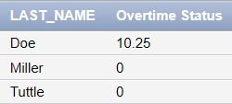

1. For all null values in the specialty column in the DJs on Demand d_partners table,  substitute “No Specialty.” Show the first name and specialty columns only.

→ SELECT first_name,

NVL2(specialty, specialty, 'No Specialty')

AS "Specialty"

FROM d_partners

ORDER BY first_name;

Atau :

SELECT first_name,

COALESCE(specialty, 'No Specialty')

AS "Specialty"

FROM d_partners

ORDER BY first_name;

Result :

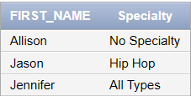

1. Use the Oracle Database employees table and CASE expression to decode the departmen id. Display the department id, last name, salary and a column called “New  Salary” whose value is based on the following conditions:

* If the department id is 10 then 1.25 * salary
* If the department id is 90 then 1.5 * salary
* If the department id is 130 then 1.75 * salary
* Otherwise, display the old salary

→ SELECT department_id "ID", last_name, salary,

CASE department_id

WHEN 10 THEN 1.25*salary

WHEN 90 THEN 1.5*salary

WHEN 130 THEN 1.75*salary

ELSE salary

END AS "New Salary"

FROM employees

ORDER BY department_id;

Result :

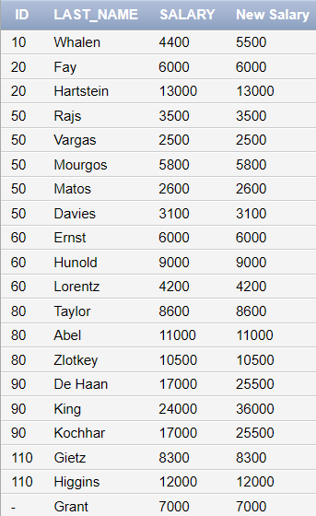

1. Display the first name, last name, manager ID, and commission percentage of all  employees in departments 80 and 90. In a 5th column called “Review”, again display the  manager ID. If they don’t have a manager, display the commission percentage. If they  don’t have a commission, display 99999.

→ SELECT first_name, last_name, manager_id, commission_pct,

COALESCE(manager_id, commission_pct, 99999)

AS "Review"

FROM employees

WHERE department_id IN (80,90)

ORDER BY first_name;

Result :

